AVAILABLE JULY 2008!

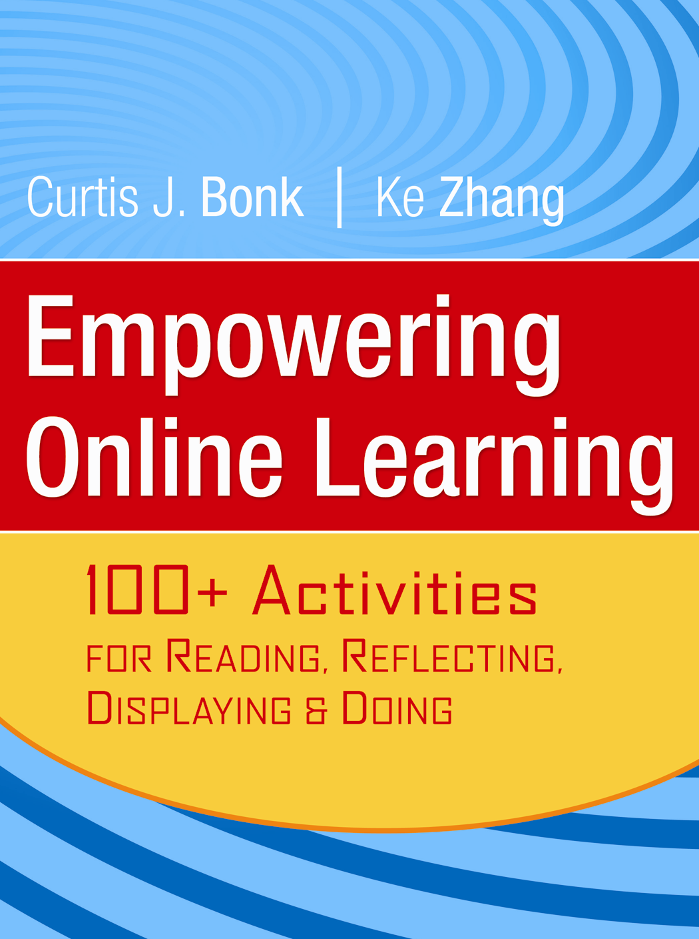

EMPOWERING

Online Learning

100+ Activities for

Reading, Reflecting, Displaying & Doing

Curtis J. Bonk | Ke Zhang
Save 20%!
with this order form

“Curt Bonk and Ke Zhang have not only forged new territory with their R2D2 model, they have proven that online learning can be responsive to student learning preferences and should be more than a “read and discuss” proposition…This model unleashes the potential that online learning holds and demonstrates that learning online can be fun!”
- Rena M. Palloff and Keith Pratt, Program Directors and Faculty,
Teaching in the Virtual Classroom Program, Fielding Graduate University

Empowering Online Learning is an essential resource for anyone designing or facilitating online learning. It introduces an easy, practical model called R2D2 (read, reflect, display, and do) that will show online educators how to deliver content in ways that benefit all types of learners (visual, auditory, observational, and kinesthetic) from a wide variety of backgrounds and skill levels. With a solid theoretical foundation and concrete guidance and examples, this book can be used as a handy reference, a professional guidebook, or a course text. This book is intended to help online instructors and instructional designers, as well as those contemplating such positions, to design, develop, and deliver learner-centered online instruction.

is Professor of Instructional Systems Technology and adjunct in Informatics at Indiana University. He also spent 15 years as a professor of educational psychology. Dr. Bonk has received the CyberStar Award from the Indiana Information Technology Association, the Most Outstanding Achievement Award from the U.S. Distance Learning Association, and the Most Innovative Teaching in a Distance Education Program Award from the State of Indiana. He has over 200 publications and during the past three years he has presented nearly 300 talks related to online teaching and learning.

is an Assistant Professor of Instructional Technology at Wayne State University with a Ph.D. in Instructional Systems from Penn State University. She has years of success in designing, developing, and teaching online courses and programs, together with fruitful research on online learning.
0-7879-8804-9 | 978-0-7879-8804-3 | Paper | 336 pp. | US$ 40.00 | CAN$ 43.99

Curt Bonk

Ke Zhang
Please send me the following: Empowering Online Learning
By Curtis J. Bonk and Ke Zhang
ISBN: 978-0-7879-8804-3 | Paper | 336 pp. | US$ 40.00

Name __________________________________________
Address_________________________________________
_________________________________________
City_______________________ State______Zip________
Payment Enclosed. All payments must be in U.S. dollars.
(Payable to John Wiley & Sons)

Check/Money order
Visa
American Express
MasterCard
Card no. |_|_|_|_|_|_|_|_|_|_|_|_|_|_|_|_|
Exp. Date___________ Day Phone____________
Signature__________________________________

Prices listed are for domestic United States customers and are subject to change without notice. Availability subject to stock on hand.

Book Price $______ Shipping $______ Sales Tax $______ Total $______
Please add shipping charges:
MerchandiseSurface 2-Day 1-Day
First Book$5.00 10.50 17.50
Each additional book $3.00 3.00 4.00
Quantity discounts available. Please call 800.956.7739.

Jossey-Bass, A Wiley Imprint ● 10475 Crosspoint Drive, Indianapolis, IN 46256 ● PH: 800.956.7739 ● FX: 800.605.2665 ● www.jbp.com



